Buck Converter Transfer Functıon Derivation

Average Model & Small Signal Circuits

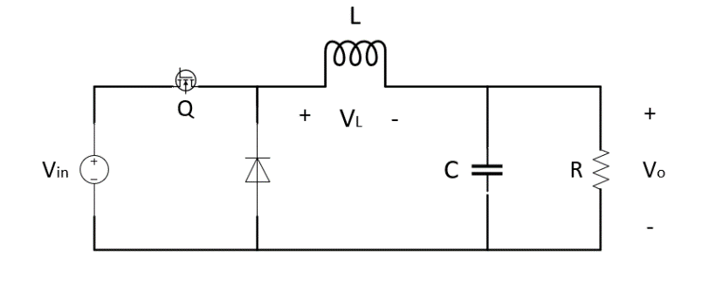

Figure . Buck Converter

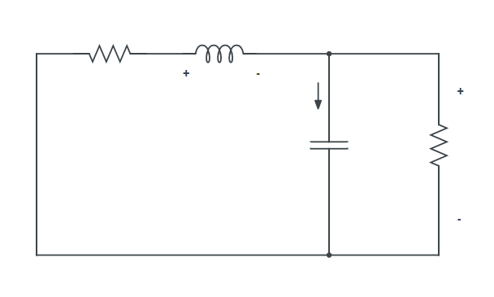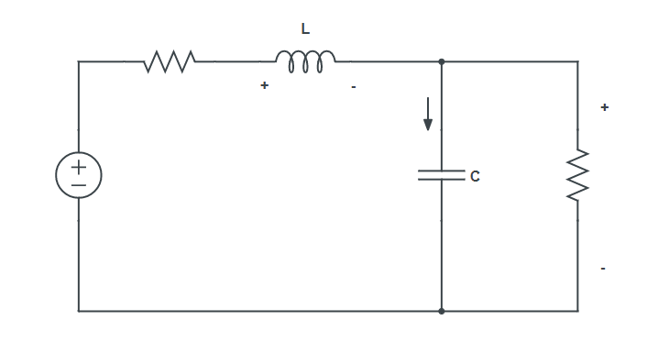*Interval I:* *Interval II*:

C

L

1. **Averaged, Small Signal Circuit Description**

1. **Capacitor Charge & Volt. Second Balance Equations**
2. **Small Signal ‘’hat’’ Terms ( x(t) = X + )**

*Inductor:*

Single hat terms:

**Averaged Small Signal**

DC Terms:

**Averaged steady-state DC eqn.**

*Capacitor:*

Single hat terms:

**Averaged Small Signal**

DC Terms:

**Averaged Steady-State DC eqn**

*Input Current:*

**Very small compared to DC values, ignored.**

→ Averaged small signal

→ Steady-state DC signal

Small signal and steady-state DC signal analysis has been implemented. Now, they should be merged in one circuit to get the transfer function of the system.

*Inductor:*

Small Signal Eqn:

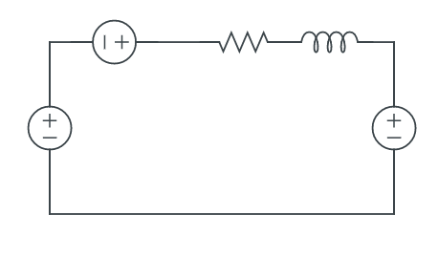

*Input Current:*

Small Signal Eqn:

**>**

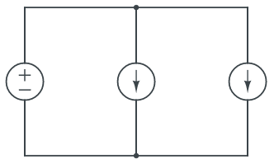

*Capacitor:*

Small Signal Eqn:

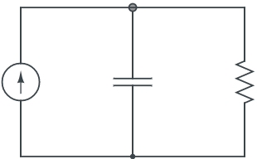

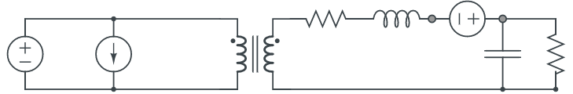

1. **Control-to-Output Transfer Function**

If there is no resistance of the inductor, use this formula:

©This document is prepared by Eren Alpaslan. All copyrights are belong to itself.